Future of Work in the Age of AI

Objective:
The objective of this project is to analyze how Artificial Intelligence (AI) is transforming the workforce by evaluating key factors such as automation risk, AI adoption, salary changes, skill gaps, and job disruption across industries and countries.

Data Source:
https://www.kaggle.com/datasets/algozee/future-of-work-in-the-age-of-ai-20202026
The dataset was obtained from Kaggle and contains workforce-related data from 2022 to 2026.
For this analysis, the data was filtered to include only 2025 and 2026, focusing on near-future trends.

Data Preparation (Excel):
- Removed duplicates (none found)
- Checked and handled missing values (no null values present)
- Standardized data formats:
- Converted percentage columns appropriately
- Formatted salary columns in USD
- Created new derived columns:
- AI Impact Category (Low, Medium, High)
- Skill Gap Category (Small, Medium, Large)
- Future Job Status (Highly automatable, Moderate Risk, Safe Job)
- Salary Difference (Before vs After AI)

Data Modelling & Visualization (Power BI):
Measures Created:
- Average Automation Risk
- Average Salary Change
- Average AI Adoption Level
- Average Reskilling Urgency
- Average Skill Gap Index
- AI Disruption Intensity

Dashboard Pages & Visualizations:
1. Automation Risk & Industry Insights
Average Automation Risk by Industry (Bar Chart)
Salary Change by Job Role (Column Chart)

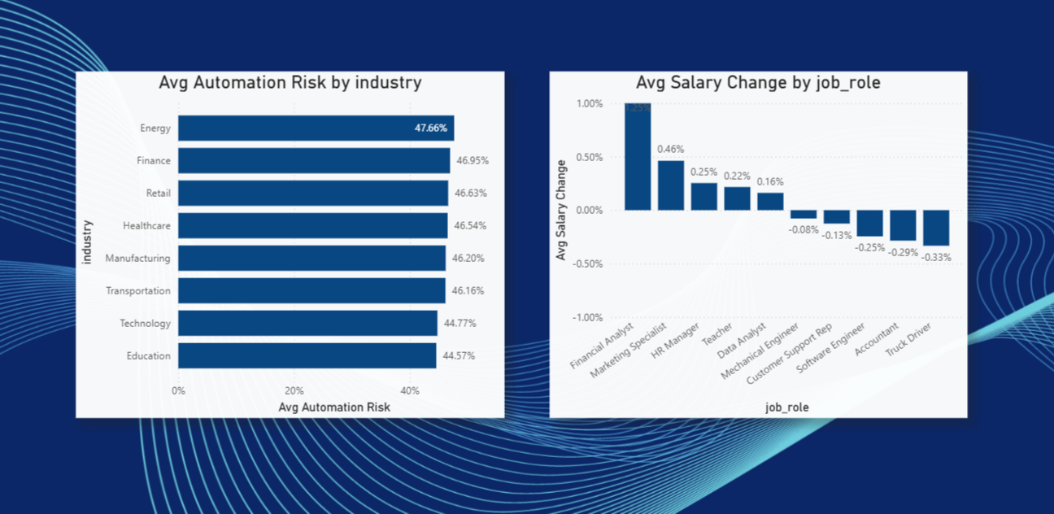

2. Global AI Adoption Landscape
AI Adoption Level by Country (Map Visualization)

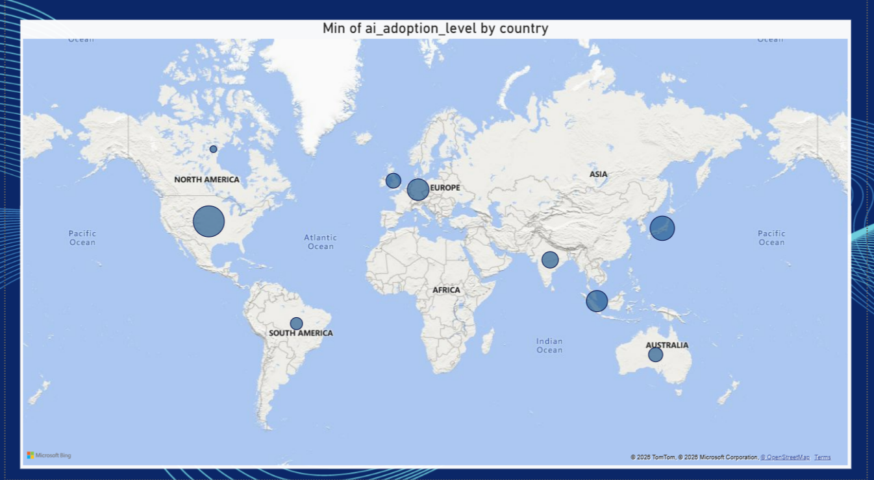

3. Impact of AI on Salaries
Scatter Plot:
AI Disruption Intensity vs Salary Change %
Segmented by Job Roles

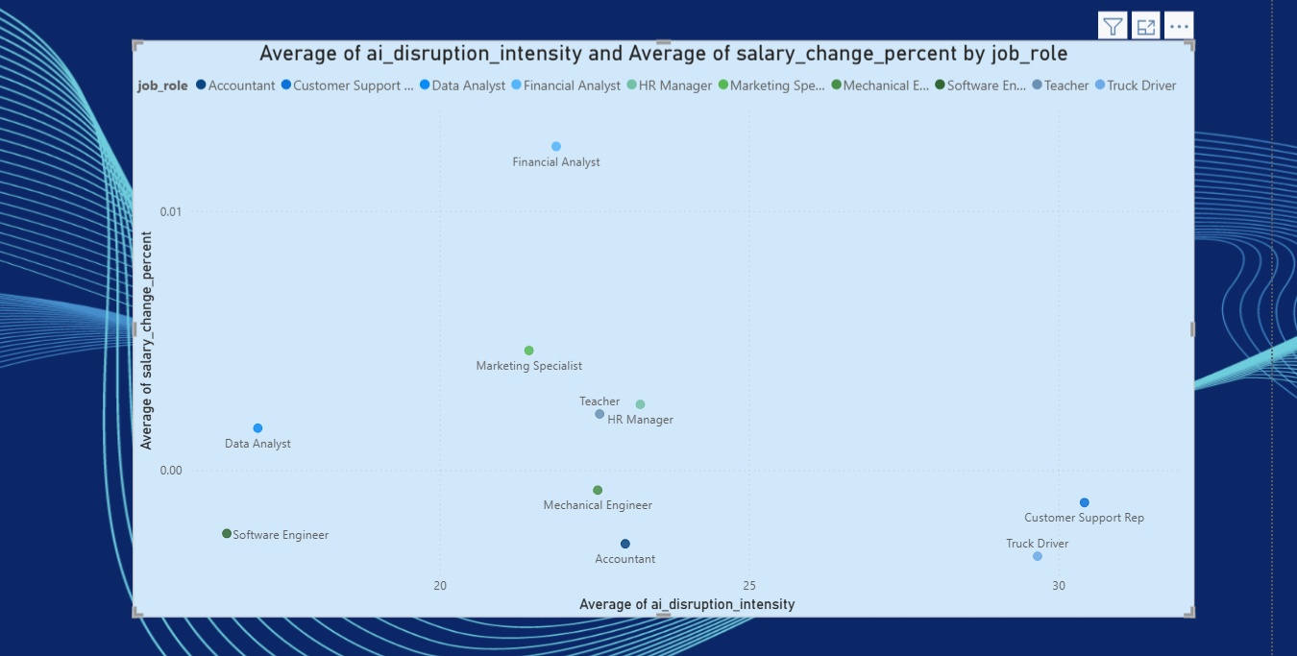

4. Skill Gap Trends Across Industries and year
Skill Gap Index by Industry and Year (Bar Chart)

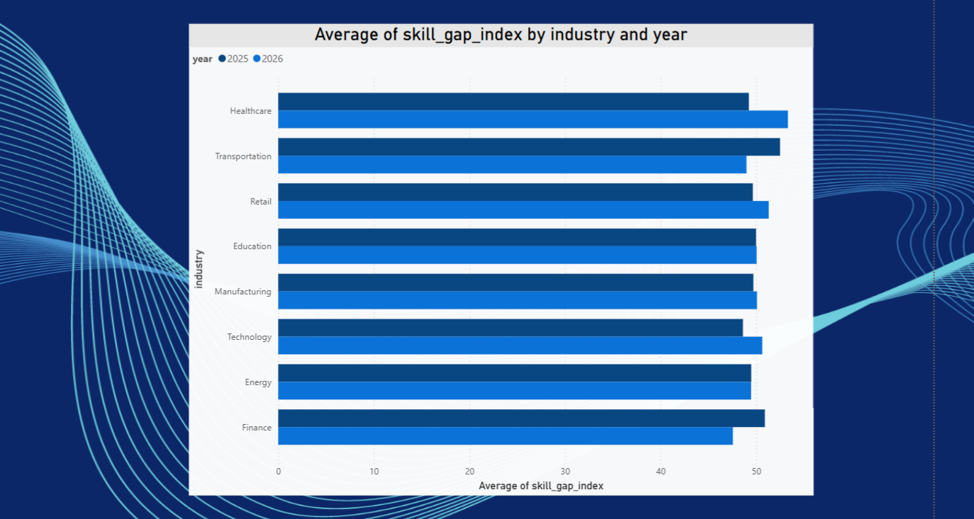

5. Key Workforce Metrics
KPI Cards:
- Average Automation Risk
- Average Reskilling Urgency
- Average AI Adoption Level
- Average Salary Change
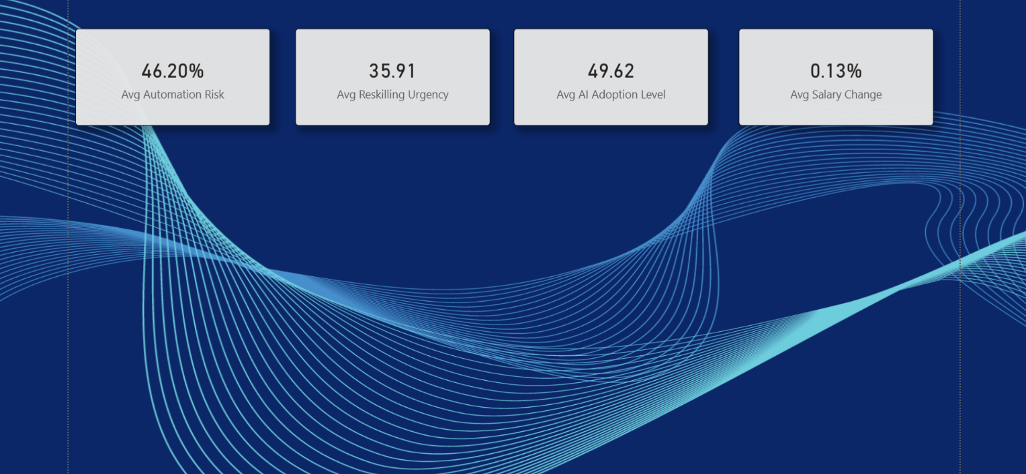
6. Executive Dashboard
Combined view of all key visuals
Interactive slicers:
Year (2025, 2026)
Country
Industry
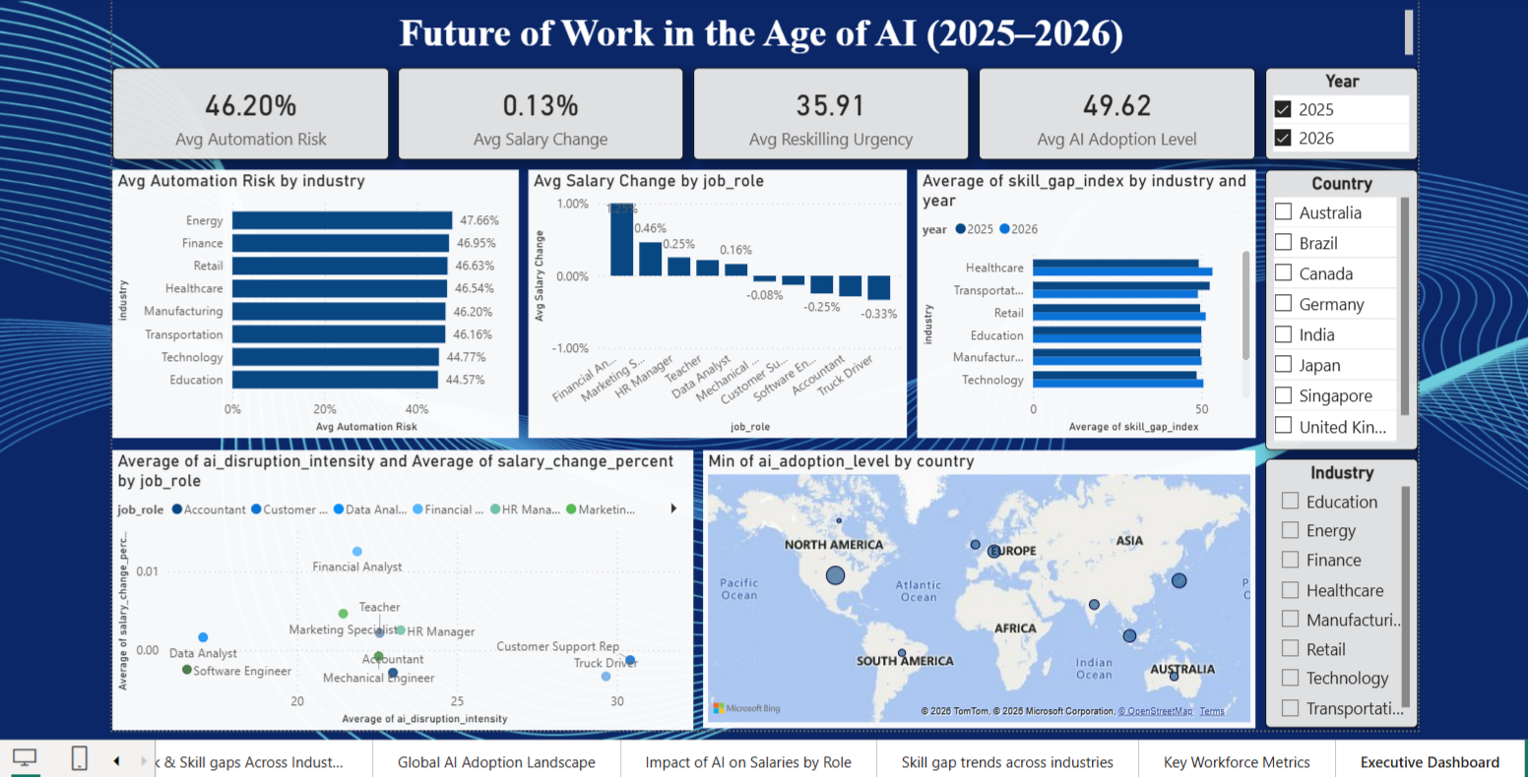
KEY INSIGHTS
1. High Automation Risk Across Industries
Industries like Energy, Finance, and Retail show higher automation risk (~46%)
Indicates significant potential for job transformation or displacement
2. Moderate AI Adoption but Growing Impact
AI adoption levels are steadily increasing across countries
Developed regions show higher adoption, indicating faster transformation
3. Uneven Salary Impact
Some roles (e.g., Financial Analysts) show salary growth
Others (e.g., Customer Support, Truck Drivers) show decline
(This Suggests AI is creating both opportunities and displacement)
4. Rising Skill Gap Across Industries
Skill gap index remains high across all industries
Indicates urgent need for upskilling and reskilling
5. High Reskilling Urgency
Reskilling urgency score (~35+) shows workforce needs rapid adaptation
Strong correlation between:
AI disruption
Skill gaps
Job transformation
6. AI Disruption vs Salary Relationship
Scatter plot shows:
Higher disruption does not always mean higher salary
Indicates role-dependent impact of AI

Conclusion:
The analysis highlights that AI is significantly reshaping the future of work. While it creates opportunities in certain roles, it also introduces risks such as job displacement and widening skill gaps. Organizations and individuals must prioritize continuous learning and reskilling to remain competitive in the evolving job market.
Tools Used:
Excel (Data Cleaning & Transformation)
Power BI (Data Modelling & Visualization)

